Outreach Activities
Participation in the 6th Asian Air Pollution and Climate Change Workshop (AAPC), Tsukuba, Japan
20 to 22 November 2025

The AirQC team participated in the 6th Asian Air Pollution and Climate Change Workshop (AAPC) held in Tsukuba, Japan. Representing AIT and AirQC, Prof. Nguyen Thi Kim Oanh delivered a keynote speech and engaged with researchers and experts from across Asia and Europe. The workshop brought together 36 participants from eight countries, creating a dynamic platform for scientific dialogue on the interactions between air pollution, climate change, and ecosystem impacts. The event aimed to promote open scientific exchange in the spirit of the long-standing Air Pollution Workshop tradition in North America, emphasizing interactive discussion over formal presentations. AAPC provides a collaborative environment for scientists working on air pollution and climate change, with a strong focus on vegetation impacts, emission mitigation strategies, and long-term cross-border environmental cooperation. The workshop encouraged research networking within Asia and globally, with the goal of strengthening regional responses to air quality and climate challenges. Prof. Kim Oanh delivered a keynote presentation titled “Multiple Benefits of Emission Reduction from Thermal Power Plants in Southeast Asia.” She highlighted the co-benefits of emission mitigation for air quality improvement, climate protection, and ecosystem preservation. The AirQC team also contributed to discussions throughout the workshop, sharing AirQC’s research insights and fostering new collaborations with regional and international partners. More information about the workshop is available at the AAPC official page: https://sites.google.com/go.tuat.ac.jp/aapctsukuba/home
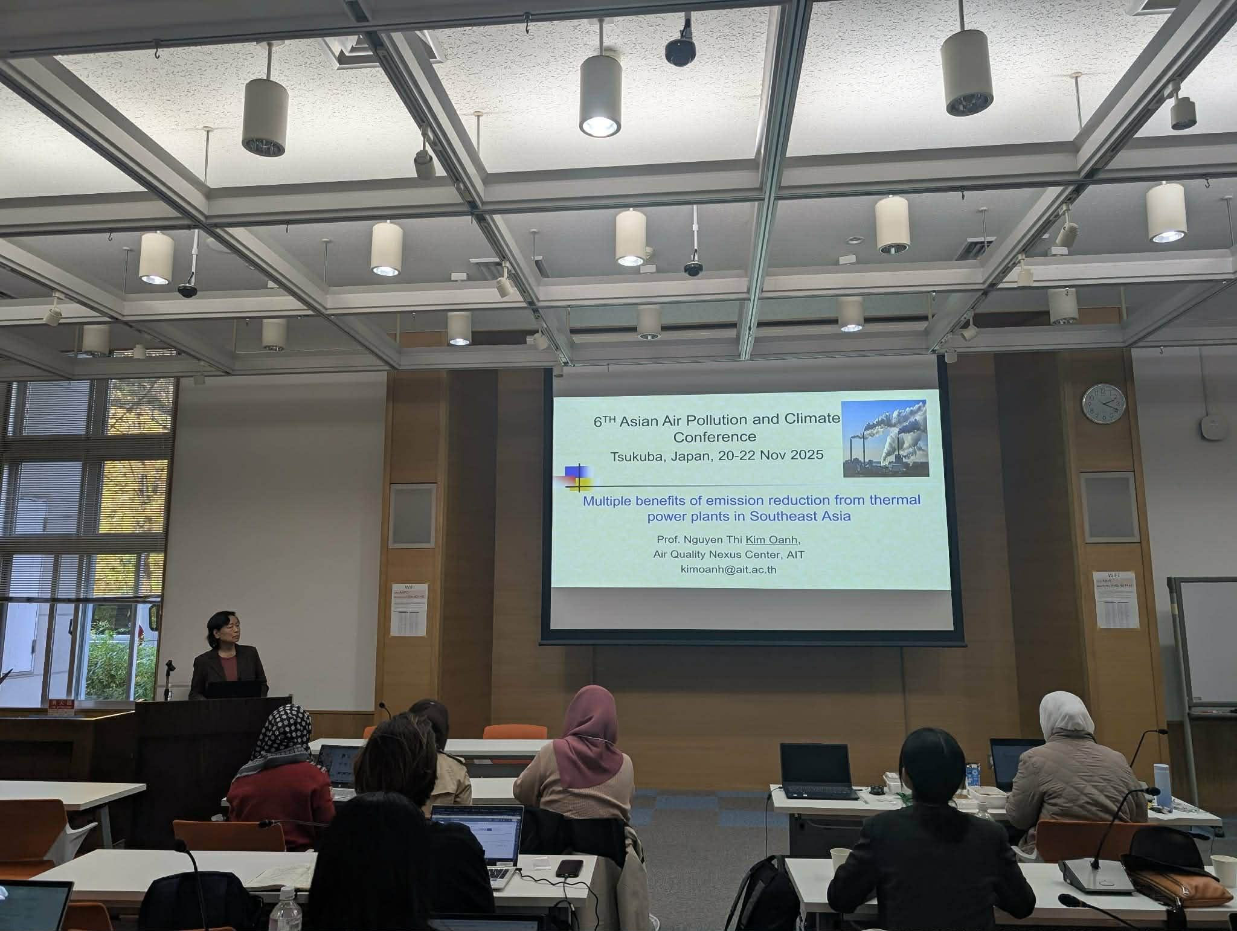
(Photo in download file)
Visit to the Ministry of the Environment of Japan (MoEJ), Tokyo, Japan
18 November 2025
Prof. Nguyen Thi Kim Oanh and Dr. Lai Nguyen Huy of the AirQC Team conducted an official visit to the Ministry of the Environment of Japan (MoEJ) in Tokyo. The meeting was part of AirQC’s ongoing engagement with regional partners to strengthen cooperation on air quality management, science-based policymaking, and joint research initiatives. The visit aimed to review progress under existing collaborations and explore new opportunities for joint activities. Discussions focused on enhancing regional air quality monitoring capacity, advancing emissions inventory development, supporting transboundary air pollution research, and expanding cooperation under emerging projects related to air-health resilience and climate co-benefits. During the meeting, Prof. Kim Oanh and Dr. Huy shared updates on AirQC’s current research programs and highlighted areas where scientific collaboration between AIT and MoEJ can create meaningful regional impact. Both sides expressed strong interest in advancing collaborative research, capacity-building efforts, and policy-oriented initiatives to support cleaner air and healthier communities across Asia.
(Photo in download file)

Participation in the Clean Air Week 2025, Sukosol Hotel, Bangkok.
24 to 28 November 2025
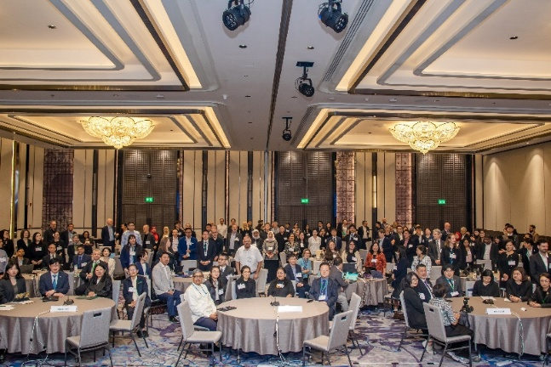
The AirQC team participated in Clean Air Week 2025, held at the Sukosol Hotel in Bangkok. The event gathered policymakers, researchers, international organizations, and regional partners to advance dialogue and action on air quality and climate challenges across the Asia-Pacific region. Throughout the week, AirQC researchers contributed to discussions, presented recent findings, and supported the organization of key technical sessions. Clean Air Week 2025 aimed to promote coordinated regional responses to persistent air pollution challenges in Asia, where fine particulate matter (PM2.5) remains among the highest globally. The event highlighted priority issues—including emissions from transport, industry, fossil fuel combustion, agriculture, domestic fuel use, brick kilns, and open waste burning—while emphasizing the multiple benefits of improved air quality for public health, climate mitigation, and sustainable development. The meeting reinforced regional commitments under UNEA-6 Resolution 6/10, which calls for strengthened cooperation to advance clean air solutions across the region. In Section 2: Regional Solutions to Address Open Burning of Agricultural Crop Residues, Prof. Nguyen Thi Kim Oanh, Director of AirQC, delivered a presentation titled “Crop Residue Open Burning vs. Other Landscape Fires in Southeast Asia: Emissions and Effects.” Her talk addressed major emission sources, the comparative impacts of different fire types, and the urgent need for coordinated airshed-based mitigation strategies. Prof. Kim also shared ongoing insights from AirQC’s regional research supporting evidence-based policy development. For more information about Clean Air Week 2025, please visit: https://www.unep.org/events/unep-event/clean-air-week

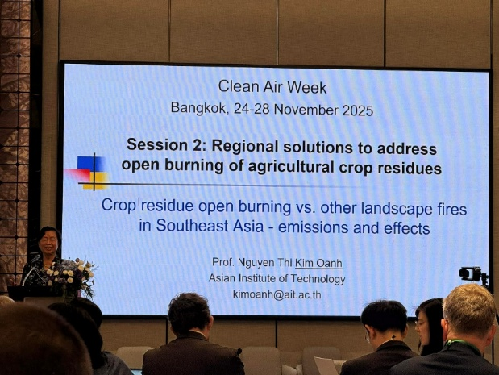
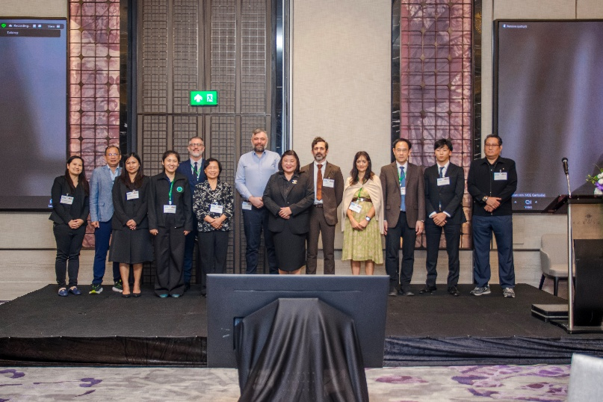
International Conference and the 14th Croatian Scientific and Professional Meeting “Air Protection 2025.” , Hotel Kolovare, Zadar, Croatia
22 to 25 October 2025
From 22 to 25 October 2025, Prof. Nguyen Thi Kim Oanh, Director of the AirQC, participated online in the International Conference and the 14th Croatian Scientific and Professional Meeting “Air Protection 2025.” The event, held at Hotel Kolovare in Zadar, Croatia, was organized by the Croatian Air Pollution Protection Association (CAPPA) in partnership with the Institute for Medical Research and Occupational Health (IMI), the Croatian Meteorological and Hydrological Service (DHMZ), and the European Federation of Clean Air and Environmental Protection Associations (EFCA). The conference was convened under the auspices of the International Union of Air Pollution Prevention and Environmental Protection Associations (IUAPPA) and brought together international experts and practitioners in air quality management. The conference aimed to provide a platform for presenting new scientific findings, discussing policy and regulatory approaches, and strengthening international cooperation in air pollution prevention. Sessions covered a broad range of topics including emission sources, atmospheric processes, health impacts, mitigation strategies, and innovative technologies. The event fostered active knowledge exchange between researchers, policymakers, and technical specialists across Europe and beyond. On 24 October 2025, Prof. Nguyen Thi Kim Oanh delivered an invited lecture titled “Biomass Open Burning in Southeast Asia: Emissions and Multiple Effects.” In her lecture, she highlighted the major sources and drivers of biomass burning in the region, its significant impacts on air quality, ecosystems, and human health, and the need for coordinated regional policies to mitigate biomass burning emissions. The conference Book of Abstracts is available here:
https://zastitazraka.imi.hr/wp-content/uploads/2025/11/Zbornik_sazetaka-2025_online.pdf

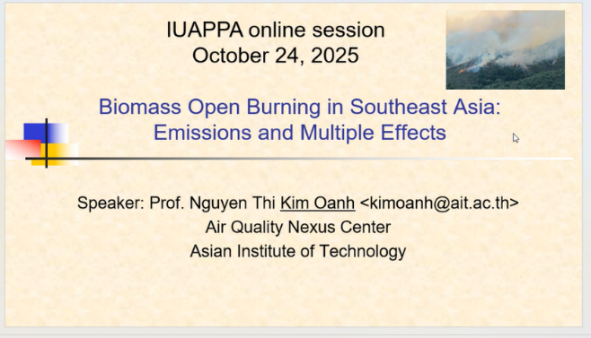

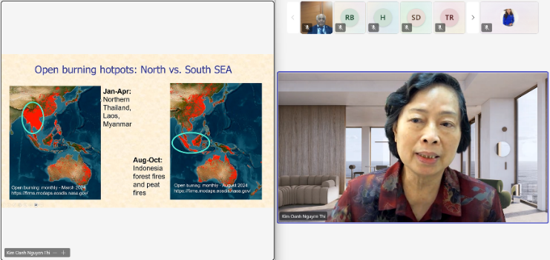

International Conference on “Current Trends in Natural Product Research”, Banaras Hindu University (BHU), Varanasi, India

On 10 December 2025, the Air Quality Nexus Center (AirQC) participated in the International Conference on “Current Trends in Natural Product Research”, an international forum that brought together students, researchers, professionals, and industry representatives to exchange knowledge on recent scientific advances and emerging research directions in natural product research. The conference aimed to accelerate research and knowledge sharing through high-quality keynote lectures, engaging panel discussions, and oral and poster presentations. The program fostered interdisciplinary dialogue and strengthened understanding of diverse concepts, methodologies, and applications related to natural products, while promoting collaboration between academia, research institutions, and industry. During the conference, Nguyen Thi Kim Oanh, Director of AirQC, delivered a presentation titled “Renewable Energy Transition: Multiple Benefits for Air Quality, Health, Ecosystems, and Climate.” Her presentation highlighted the co-benefits of transitioning to renewable energy systems, emphasizing evidence-based pathways to simultaneously reduce air pollution, improve public health, protect ecosystems, and mitigate climate change, in line with AirQC’s integrated nexus approach.
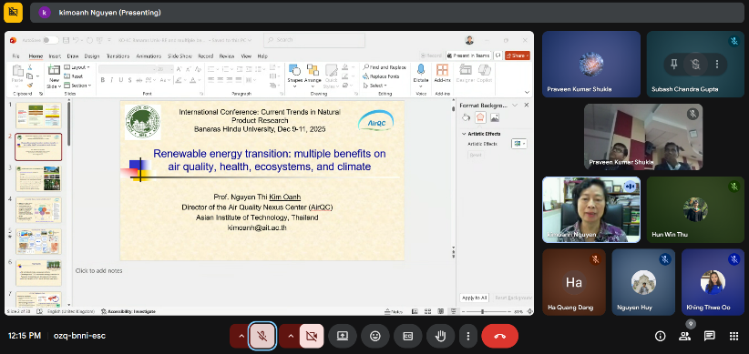

Second Lead Author Meeting of the Intergovernmental Panel on Climate Change (IPCC) Task Force on National Greenhouse Gas Inventories (TFI), Boğaziçi University Cultural Center, Albert Long Hall in Istanbul, Türkiye

From 7 to 9 October 2025, Prof. Nguyen Thi Kim Oanh, Director of the Air Quality Nexus Center (AirQC), participated online in the Second Lead Author Meeting of the Intergovernmental Panel on Climate Change (IPCC) Task Force on National Greenhouse Gas Inventories (TFI). The meeting, held at the Boğaziçi University Cultural Center, Albert Long Hall in Istanbul, Türkiye, followed an official invitation from the Co-Chairs of the IPCC TFI to contribute to the development of the upcoming methodology report. The meeting aimed to advance the preparation of the 2027 IPCC Methodology Report on Inventories for Short-Lived Climate Forcers (SLCFs) by reviewing draft chapters, aligning methodological approaches, and incorporating the latest scientific evidence. It provided a platform for Lead Authors and contributing experts to collaborate on improving accuracy, transparency, and consistency in national SLCF inventory reporting. Prof. Kim Oanh contributed online. She is the lead author of Chapter 1, Chapter 3 and Chapter 4 of the report.

Link to Project
Healthy Environment and Lives (HEAL) 2025 Conference
From 3 to 6 November 2025, the Air Quality Nexus Center (AirQC) participated in the Healthy Environment and Lives (HEAL) 2025 Conference, a four-day hybrid event focused on the urgent health, climate, and environmental challenges facing Australia, the Asia-Pacific region, and the world. The conference theme, “Weaving Diverse Knowledges into Climate Action for Better Health,” brought together international experts, policymakers, researchers, and community leaders across multiple hubs and virtual platforms.
The event aimed to highlight scientific evidence, community-led initiatives, and integrated policy approaches to address climate-related health impacts. The program featured national plenary sessions, thematic breakout sessions, and regional hub sessions, showcasing research supporting Australia’s National Health and Climate Strategy, regional decarbonization and adaptation plans, and the UN Sustainable Development Goals. A strong emphasis was placed on elevating First Nations knowledge, regional perspectives, and grassroots leadership across the Asia-Pacific.
On 3 November 2025, Prof. Nguyen Thi Kim Oanh, Director of AirQC, served as a panelist in the session “Scientific Evidence and Policy on Wildfire Smoke–Related Health Impacts.” She shared insights on the health risks of wildfire smoke, the need for evidence-based policy frameworks, and the importance of regional collaboration to reduce exposure and strengthen public health resilience.
The full conference program and details are available here:
https://vepimg.b8cdn.com/uploads/vjfnew/19538/uploads/vjf/content/misc/1762201689HEAL_2025_Conference_Program.pdf
